Empirical Models in Marketing

Jin Miao

**Summary**

* The authors estimated two structural models of the brand choice behavior in an environment with uncertainty about brand attributes.
* Compared with existing literature, these two models explicitly specifies the behavioral process for state dependence.

**Model**

* The variability of consumer experiences with attribute level



* Consumer’s Utility Function is the foundation for Structural Model (Lucas Critique)



* Note the source of error terms. Given the random component associated with consumer I, brand j at time t, the expected utility for brand j is

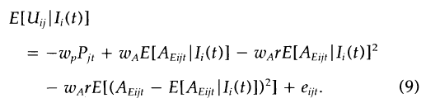

* Bayesian Learning: advertising messages also provide information about brand attribute levels. (The information precision is captured by Sigma)



* Consumers use information they receive over time to update their prior expectations of brand mean attribute levels.

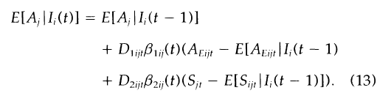

* The reduced form of the dynamic structural model with immediate utility maximization

(Lucas Critique associated with Marketing Mix variables ^delta ^sigma)

* No reduced form for the dynamic structural model with forward-looking utility maximization

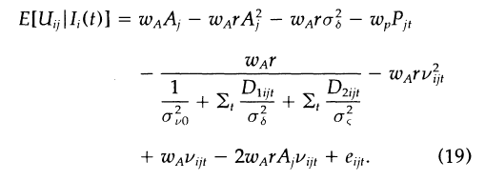

**Contributions**

* Methodological

*Lucas Critique argues that it is naive to try to predict the effects of a change in economic policy entirely on the basis of relationships observed in historical data, especially highly aggregated historical data. The Lucas critique suggests that if we want to predict the effect of a policy experiment, we should model the "deep parameters" (relating to preferences, technology, and resource constraints) that are assumed to govern individual behavior: so-called "microfoundations."*

* + Estimated parameters of consumers’ utility function are invariant to changes in the marketing mix.
  + Structural Model can be used to perform policy experiments that are impossible for nonstructural models.
  + Dynamic Programming method (Jeane & Wolpin, 1994)
  + Errors are serially correlated
* Theoretical
  + Unobserved heterogeneity is captured by endogenous signals over time.
  + This paper provides a behavioral explanation of heterogeneity (“Nurture”)
    - Is it possible to incorporate inherent heterogeneity based on demographic information (Nature)?

Strengths

* The introduction of Structural Model into marketing
* Predictive Validity
  + Validation method is robust with a different set of individuals from a different city
  + Model fits better for the in-sample and out-of-sample data
* This model is capable of explaining the mechanisms for marketing mix strategy.
  + GL: advertising has no effects; Structural Model considers message variance

**Weaknesses**

* (puzzle) [AIC and –LL] How many parameters from Table 2-4
* The estimation of the weekly discount factor
* This model implicitly assumes that every review is equally informative
  + Wu et al. (2015). *Marketing Science.* The Economic Value of Online Reviews